Week 2

**Week-02-01-PracticeSession-Coding**

**Q1)**Manypeoplethinkabouttheirheightinfeetandinches,eveninsomecountriesthatprimarilyusethe metric system. Write a program that reads a number of feet from the user, followed by a number of inch- es. Once these values are read, your program should compute and display the equivalent number of cen- timeters.

Hint:

Onefootis12inches.

Oneinchis2.54centimeters. Input Format

First line,read the number of feet. Second line, read the number of inches. Output Format

Inonelineprinttheheightincentimeters.

Note:Allofthevaluesshouldbedisplayed usingtwodecimalplaces. Sample Input 1

56

SampleOutput1

167.64

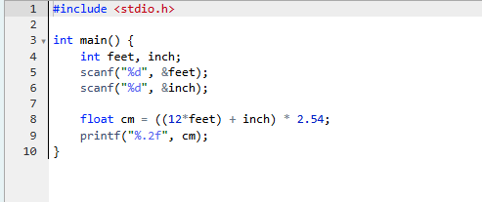

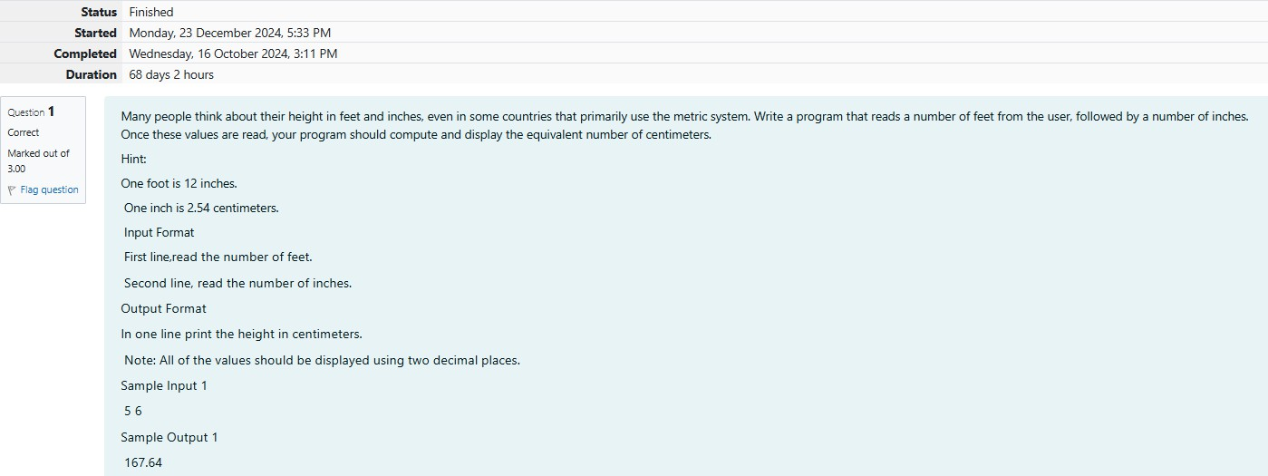

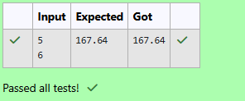Output:

**Q2)** Create aprogram thatreadstwo integers,aandb,fromthe user.Your programshouldcomputeand display: •Thesumofaandb•Thedifferencewhenbissubtractedfroma•The productofaandb•The quotient when a is divided by b • The remainder when a is divided by b

InputFormat

First line, read the first number. Second line, read the second number. Output Format

Firstline,printthesumofaandb

Secondline,printthedifferencewhenbissubtractedfroma Third line, print the product of a and b

Fourthline,printthequotientwhenaisdividedbyb Fifthline,printtheremainder whenaisdividedbyb Sample

Input 1 100 6 Sample Output 10694600164

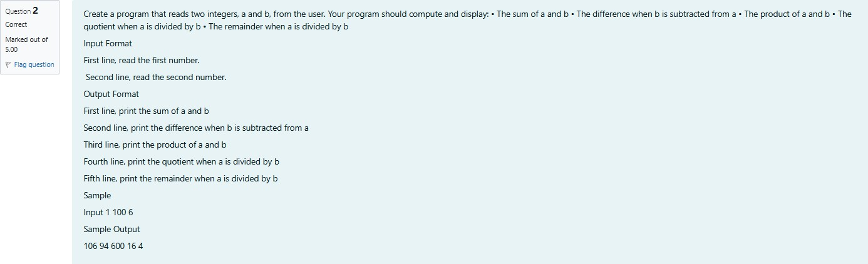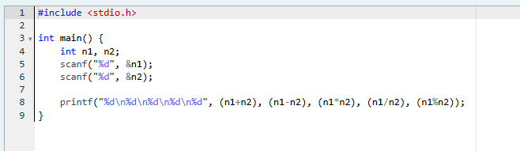

**Ouput:**

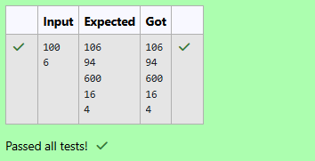

**Q3)**A bakerysells loavesof breadfor$3.49 each.Dayoldbreadis discountedby60 percent.Write a pro- gram that begins by reading the number of loaves of day old bread being purchased from the user. Then your program should display the regular price for the bread, the discount because it is a day old, and the totalprice.Eachoftheseamountsshouldbedisplayedonitsownlinewithanappropriatelabel.Allofthe values should be displayed using two decimal places.

InputFormat

Readthenumberofdayoldloaves. Output Format

First line, print Regular price: price Second line, print Discount: discount Third line, print Total: total

Note:Allofthevaluesshouldbedisplayedusingtwodecimalplaces. Sample Input 1

10

SampleOutput1

Regularprice:34.90

Discount:20.94

Total:13.96

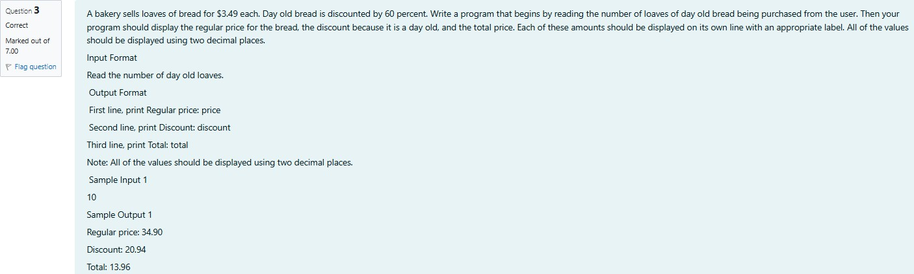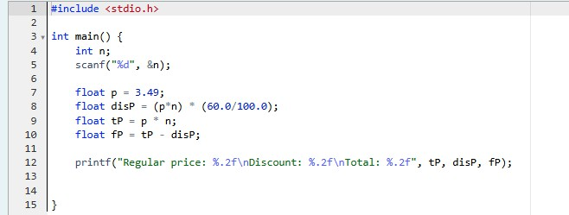

**Output:**

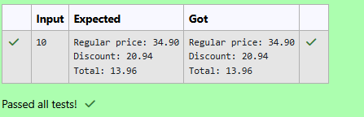

**Week-02-02-PracticeSession-Coding**

Q1) Goki recently had a breakup, so he wants to have some more friends in his life. Goki has N people whohecanbefriendswith,sohedecidestochooseamongthemaccordingtotheirskillsset Yi(1<=i<=n). He wants atleast X skills in his friends. Help Goki find his friends.

## INPUT

FirstlinecontainsasingleintegerX -denotingtheminimumskillrequiredtobeGoki'sfriend.Nextline contains one integer Y - denoting the skill of the person

## . OUTPUT

PrintifhecanbefriendwithGoki.'YES'(withoutquotes)ifhecanbefriendswithGokielse'NO'(without quotes).

## CONSTRAINTS 1<=N<=1000000

1<=X,Y<=1000000 SAMPLE INPUT 1

100110

## SAMPLEOUTPUT1 YES

SAMPLEINPUT2

10090

## SAMPLEOUTPUT2 NO

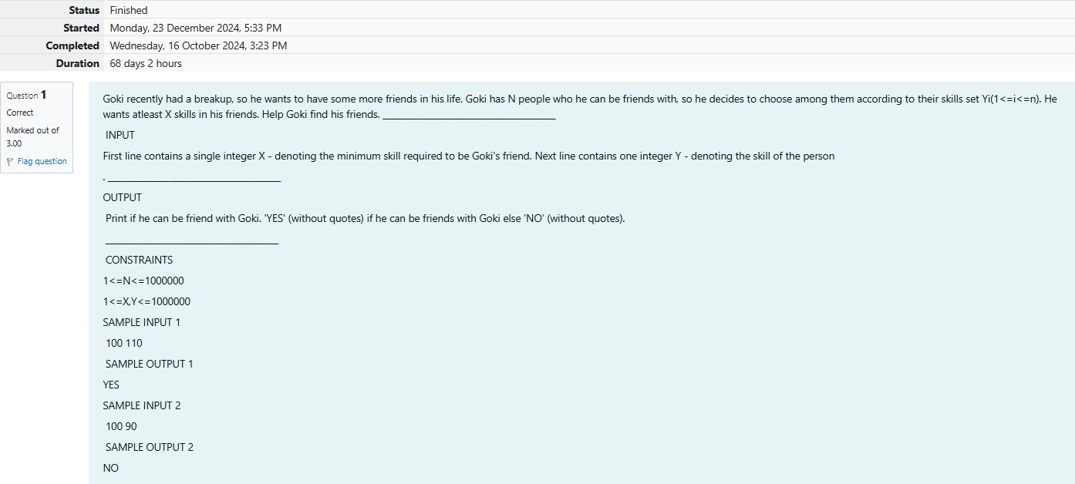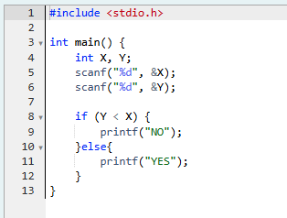

**Output:**

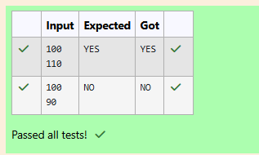

Q2)Before the outbreak of corona virus to the world, a meeting happened in a room in Wuhan. A per- sonwhoattendedthatmeetinghadCOVID-19andnooneintheroomknewaboutit!Soeveryonestarted shaking hands with everyone else in the room as a gesture of respect and after meeting unfortunately everyonegotinfected!Giventhefactthatanytwopersonsshakehandexactlyonce,Canyoutellthetotal count of handshakes happened in that meeting? Say no to shakehands. Regularly wash your hands. Stay Safe.

InputFormat

ReadanintegerN,thetotalnumberofpeopleattendedthatmeeting. Output Format

Printthenumberofhandshakes. Constraints

## 0< N<106

SAMPLEINPUT1

1

## SAMPLEOUTPUT 0

SAMPLEINPUT2

2

## SAMPLEOUTPUT2

1

ExplanationCase1:Thelonelyboard membershakesnohands,hence0.Case2:Thereare2boardmem- bers, 1 handshake takes place.

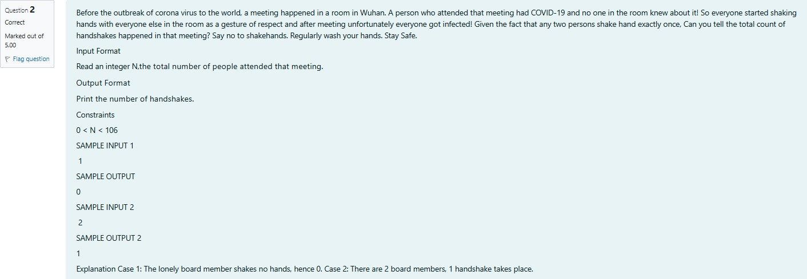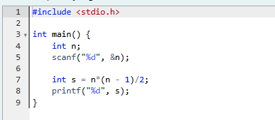

**Output:**

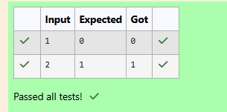

Q3) In our school days, all of us have enjoyed the Games period. Raghav loves to play cricket and is Cap- tain of his team. He always wanted to win all cricket matches. But only one last Games period is left in school now. After that he will pass out from school. So, this match is very important to him. He does not wanttoloseit.Sohehasdonealotofplanningtomakesurehisteamswins.Heisworriedaboutonlyone opponent - Jatin, who is very good batsman. Raghav has figured out 3 types of bowling techniques, that could be most beneficial for dismissing Jatin. He has given points toeachof the 3 techniques. You needto tell him whichis themaximum point value,so thatRaghavcanselect best technique. 3 numbers are given in input. Output the maximum of these numbers.

Input:

Threespaceseparatedintegers. Output:

Maximumintegervalue SAMPLE INPUT

861

## SAMPLEOUTPUT 8

ExplanationOutofgivennumbers,8ismaximum.

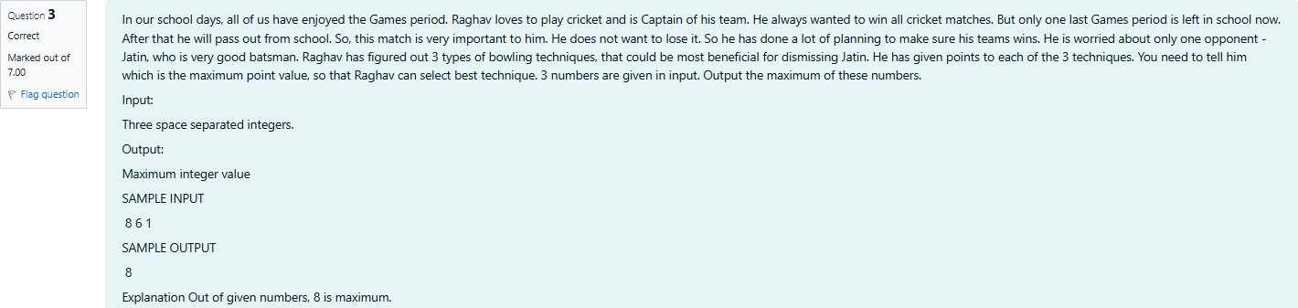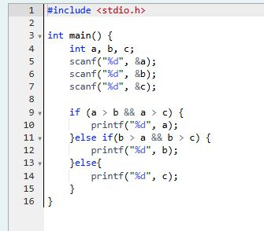

**Output:**

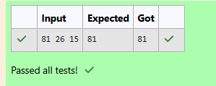

# Coding-Variablesand Keywords

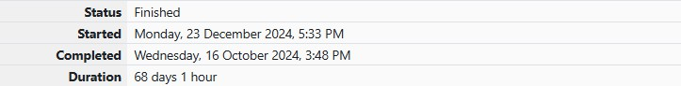

Q1)Readthecodegivenbelowtolearnnamingconventionsinidentifiers. For example, consider the program given below:

#include<**stdio.h**>

**int**main()

{

**int**age=2;//ageisanintegervariable

**int**firstNumber=2;//firstNumberisanintegervariable

//Iftherearetwoormorewordsinanidentifier/variable -Usercanalsouse"camelcase"styletodeclareavar- iable.

**int**second_number=3;//second_numberisanintegervariable

//Anyspacecannotbeusedbetweentwowordsofanidentifier/variable;Usercanuseunderscore(_)insteadof space.

**int**_i_am_also_a_valid_identifier=4;//_i_am_also_a_valid_identifierisanintegervariable

//Anidentifier/variablenamemust bestartwithanalphabetorunderscore(_)only,nootherspecialcharacters, digits are allowed as first character of the identifier/variable name.

printf("age = %d\n", age); printf("firstNumber=%d\n",firstNumber);

printf("second_number = %d\n", second_number); printf("_i_am_also_a_valid_identifier=%d\n",_i_am_also_a_valid_identifier);

return 0;

}

Fillinthemissingcodeinthebelowprogramtoprintthevaluesofthegivenvariables.

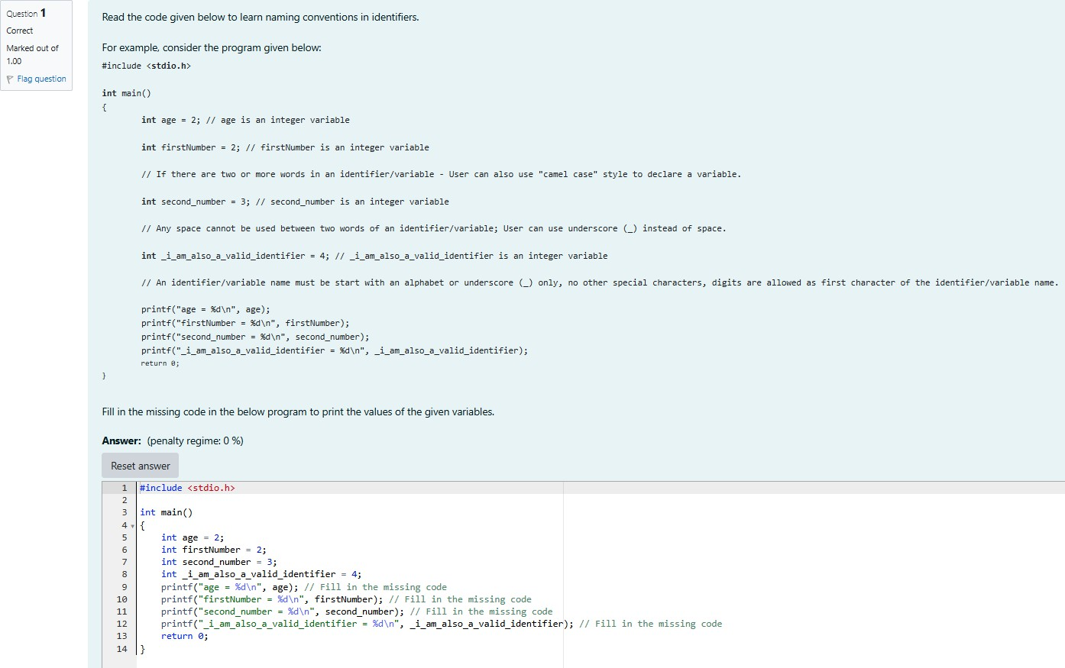

**Output:**

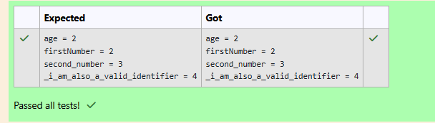

# Coding-Syntaxofmain() function

Q1)Identifyandcorrecttheerrorinthecodegiven below.

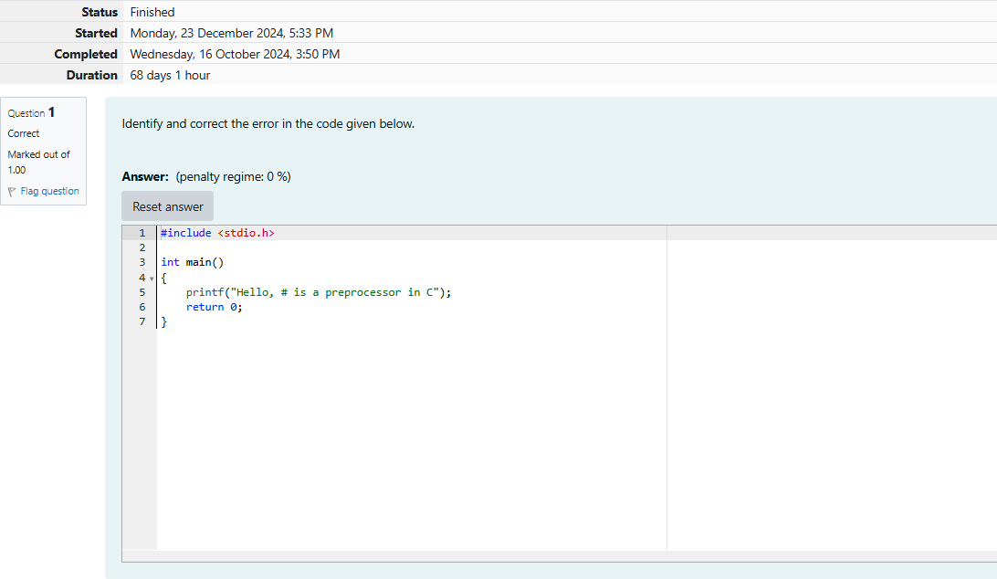

**Output:**

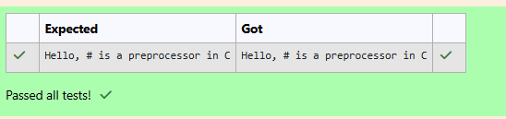

Q2)In**C**programminglanguage,executionofthecodestartswitha[function](https://en.wikipedia.org/wiki/Subroutine)calledmain.

Weshalllearnmoreaboutfunctionsin thelatersections.Fornow,wecansafelyassumethat **function**is the name given to a set of one or more executable statements. main() is a **user defined function**, i.e., a user (a programmer) writes the code for the main() function.

Whileexecutinga**C**program,the**OperatingSystem(OS)**onlycallsthemain()functioninthatprogram.

Whenthe**OS**executesaprogram,theprogramusuallyreturnsanintegervalue 0iftheexecutionofthat program is successful.

In**C**,**main()** canbewritteninsuchawaythatitreturns aan int.

**#include<stdio.h>**

**intmain()**

**{**

printf("Sample main() function with int as return type!"); return0;//0valueindicatesthattheexecutionissuccessful

**}**

Iftheprogrammerdoesnotspecifyanyreturntype,thereturntypeisbydefaultconsideredasint.

Thenameofthe main()functionshouldalwaysbeinlowercase,i.e.,ifafunctioniswrittenas Main(),itis not the main function which is called by the OS.

Readthecodegivenbelowtofamiliarizeyourselfwiththesyntaxofmain()function.Retypeinthespace provided.

#include<stdio.h> int main()

{

printf("Impossibleisnothing!"); return 0;

}

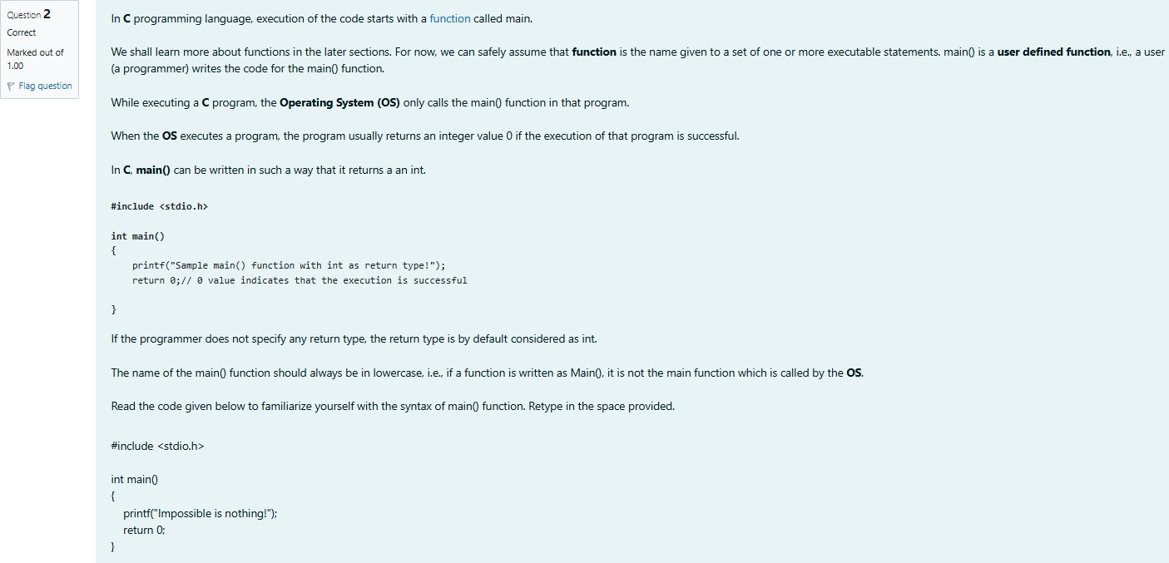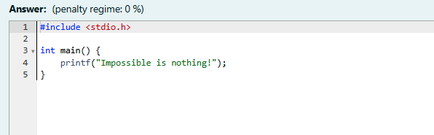

**Output:**

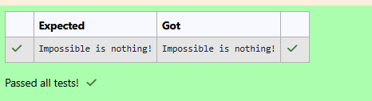

Q3)Identifyandcorrecttheerrorinthecodegiven below.

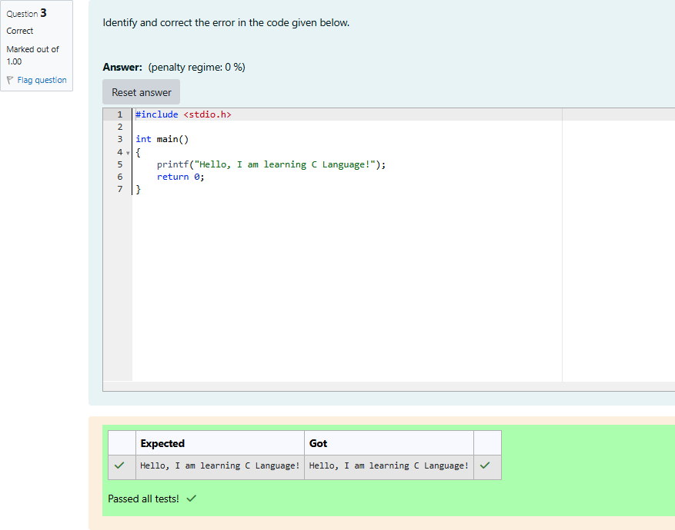

Q4)ClickonCheckwithoutcorrectingthecode.

This results in many errors because the main function is not defined correctly. Now,correctthespellingofthe mainfunctionandsubmittheprogramonceagain.

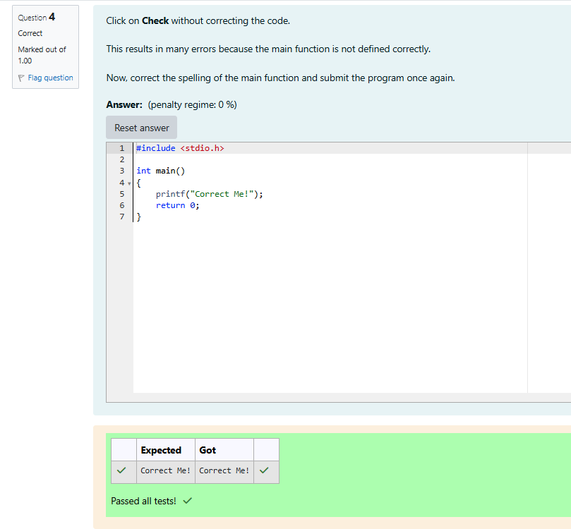

Q5)Identifyandcorrecttheerrorinthecodegivenbelow.

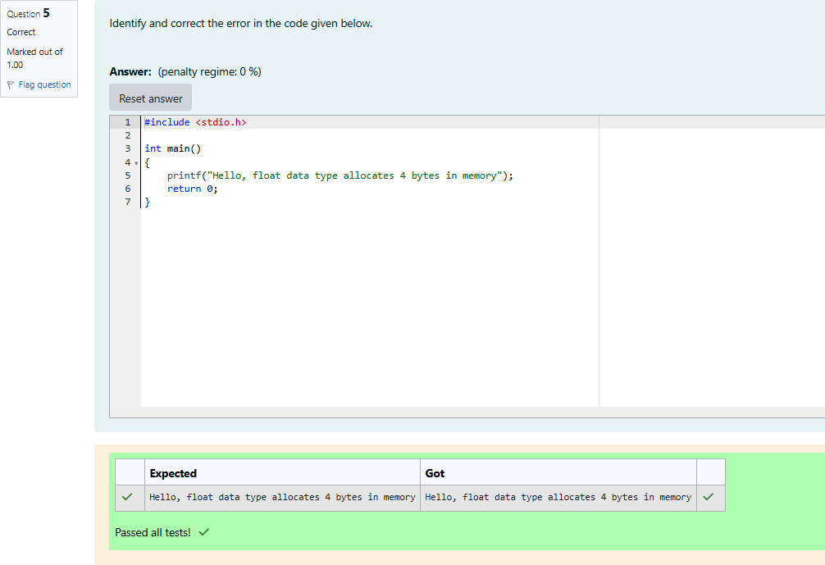

# intDataType

Q1)Intheprogramgivenbelow,weshalllearnhowtoassignvaluesto intdatatypefrombinary,octal, hex and character literals.

Readthecodegivenbelowandretypeinthespaceprovided. #include <stdio.h>

intmain()

{

intbinaryThree= 0b11;

printf("binaryThreevalue=%d\n",binaryThree); int octalEight = 010;

printf("octalEightvalue=%d\n",octalEight); int hexTen = 0xA;

printf("hexTenvalue=%d\n",hexTen); int asciiValueOfOne = '1';

printf("asciiValueOfOnevalue=%d\n",asciiValueOfOne); int asciiValueOfA = 'A';

printf("asciiValueOfAvalue=%d\n",asciiValueOfA); return 0;

}

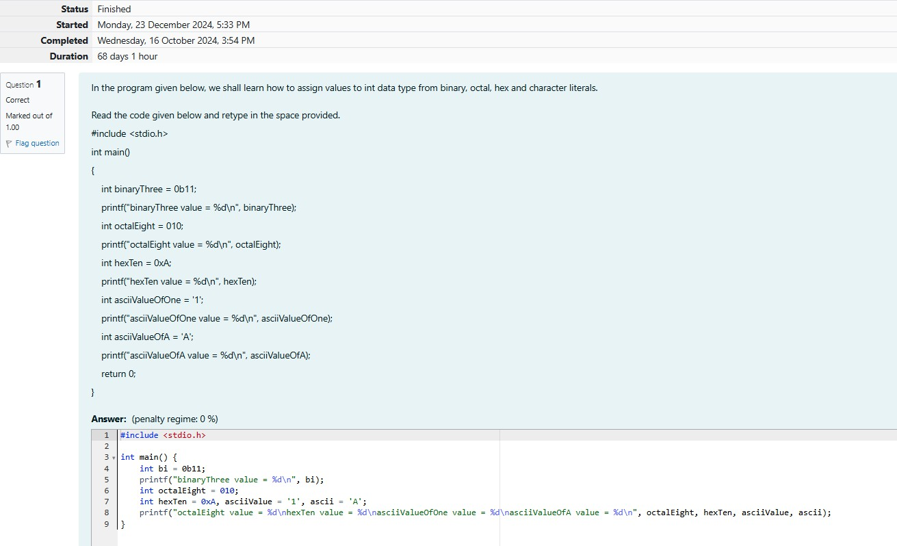

**Output:**

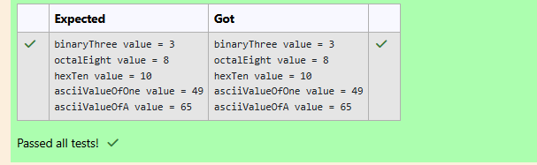

Q2)Intheprogramgivenbelow,fillinthemissingcodetoaddtwointegernumbers.

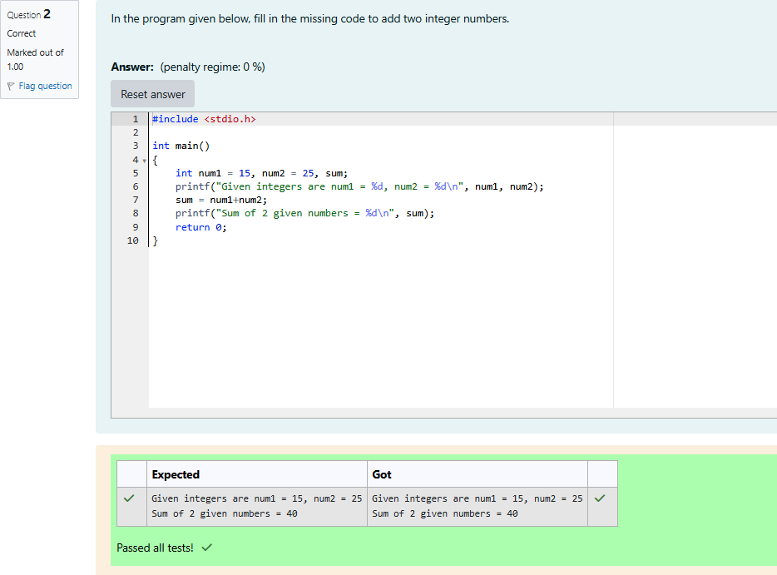

Q3)Toprintunsignedvaluesontheconsole,use%uformatcharacterinsteadof%din the **printf()** function.

Wheneveranattemptismadetoassignanegativenumbertoan**unsignedint**(Foreg:unsignedintnum=

-1;)thecompilerdoesnotflagitasan **error**.Instead,itwillautomaticallyconvertthenegativenumberto a positive number as shown below:

unsignedint**num**=-1;

The value stored in **num** = unsigned int **maximum_value** + **1** - **num**; Thefinalvaluein**num**=4294967295(ina32-bitprocessingsystem)

Intheprogramgivenbelow,fillinthemissingformatcharacterstoprintsignedandunsignedvalues.

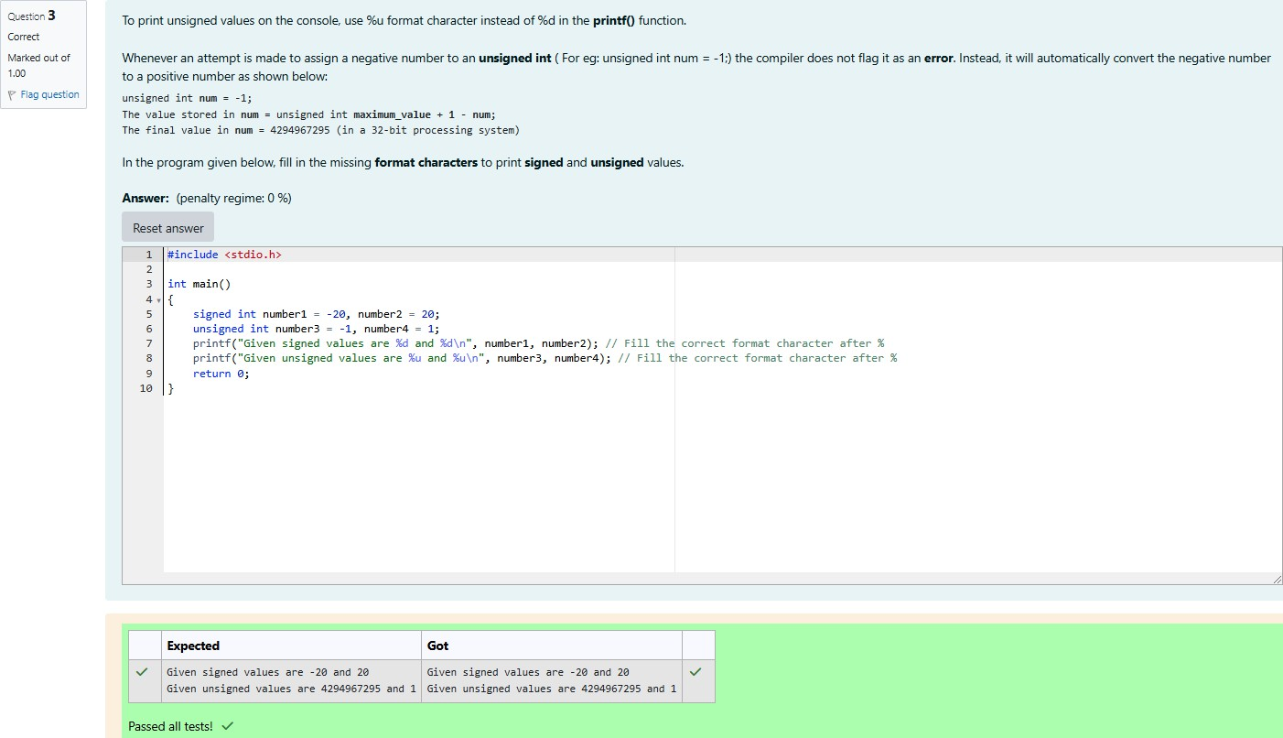

Q4)Identifytheerrorandcorrectthecode.[**Hint**:Verifyifallvariablesaredeclaredbeforetheyarefirst used.]

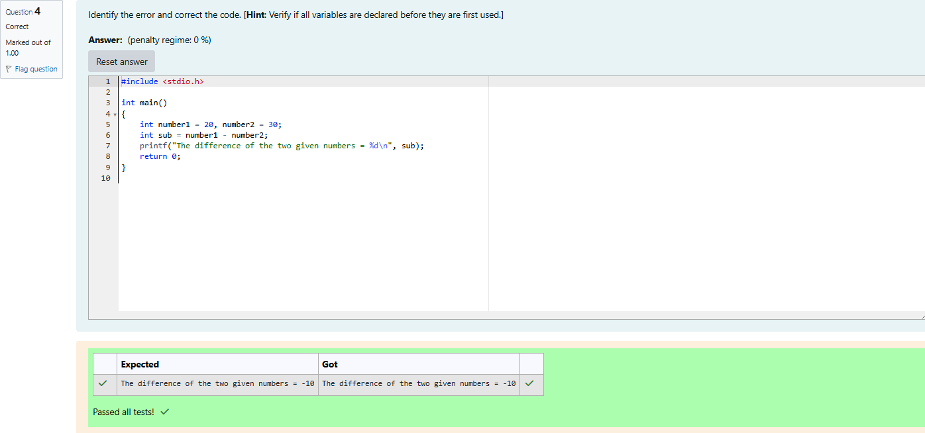

# floatData Type

Q1)Identifyandcorrecttheerrorsinthecodegivenbelow: Expected Output:

Givenfloatvaluesarenum1=5.340000,num2=125.789001 The result after dividing in float format = 23.555992

Theresultafterdividinginexponentialformat=2.355599e+01

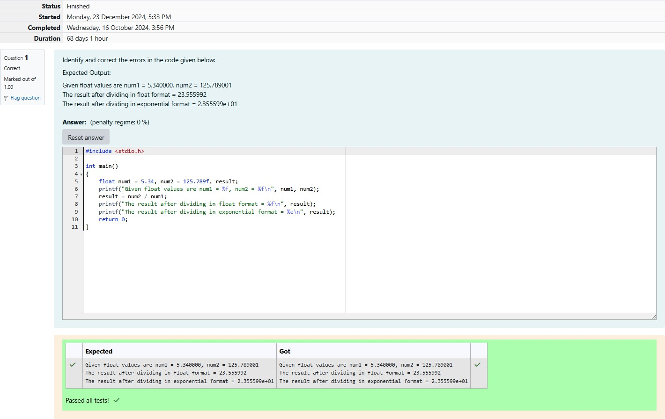

Q2)Identify andcorrect theerrors inthe codegiven below:

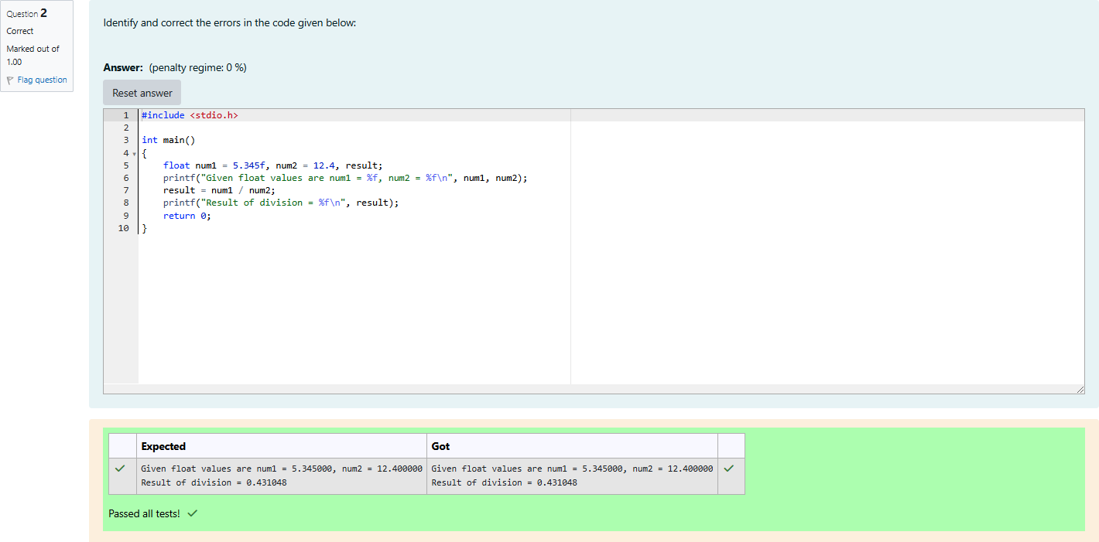

# CricketStadium

Q1)There was a large ground in center of the city which is rectangular in shape. The Corporation decides to builda Cricketstadiuminthe areaforschoolandcollegestudents, But theareawas usedas acar park- ingzone.Inordertoprotectthelandfromusingasanunauthorizedparkingzone,thecorporationwanted to protect the stadium by building a fence. In order to help the workers to build a fence, they planned to

place athickrope aroundthe ground. They wantedto buy onlythe exactlengthof theropethat isneeded. They also wanted to cover the entire ground with a carpet during rainy season. They wanted to buy only the exact quantity of carpet that is needed. They requested your help. Can you please help them by writ- ing a program to find the exact length of the rope and the exact quantity of carpet that is required?

Inputformat:

Inputconsistsof2integers.Thefirstintegercorrespondstothelengthofthegroundandthesecondinte- ger corresponds to the breadth of the ground.

OutputFormat:

OutputConsistsoftwointegers.Thefirstintegercorrespondstothelength.Thesecondintegercorre- sponds to the quantity of carpet required.

SampleInput:

50

20

Sample Output:

140

1000

Forexample:

|  |  |
| --- | --- |
| **Input** | **Result** |
| 50 | 140 |
| 20 | 1000 |

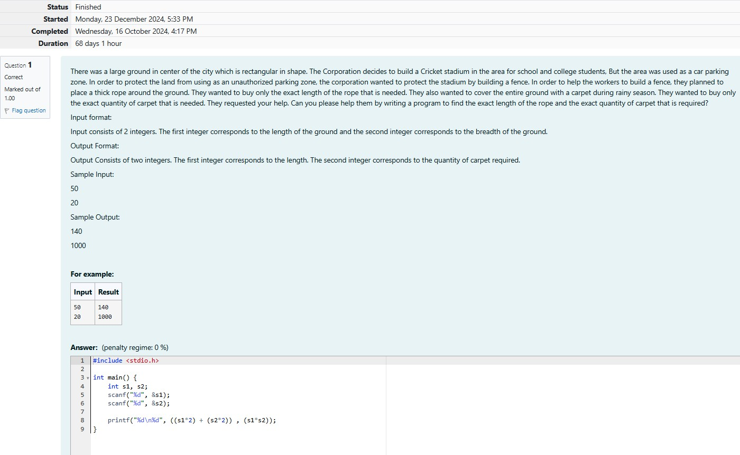

**Output:**

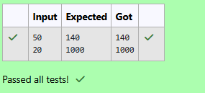

# Sports DayCelebration

Q1)Training for sports day has begun and the physical education teacher has decided to conduct some team games. The teacher wants to split the students in higher secondary into equal sized teams. In some cases, there may be some students who are left out from the teams and he wanted to use the left out studentstoassisthiminconductingtheteamgames.Forinstance,ifthereare50studentsinaclassandif the class has to be divided into 7 equal sized teams, 7 students will be there in each team and 1 student will be leftout. That 1student will assistthe PET. Withthis idea in mind, the PET wantsyour help to auto- mate this team splitting task. Can you please help him out?

## INPUTFORMAT:

Inputconsistsof2integers.Thefirstintegercorrespondstothenumberofstudentsintheclassandthe second integer corresponds to the number of teams.

## OUTPUTFORMAT:

Theoutputconsistsoftwointegers.Thefirstintegercorrespondstothenumberofstudentsineachteam and the second integer corresponds to the students who are left out.

## SAMPLEINPUT:

60

8

## SAMPLEOUTPUT:

7

4

Forexample:

|  |  |
| --- | --- |
| **Input** | **Result** |
| 60 | 7 |
| 8 | 4 |

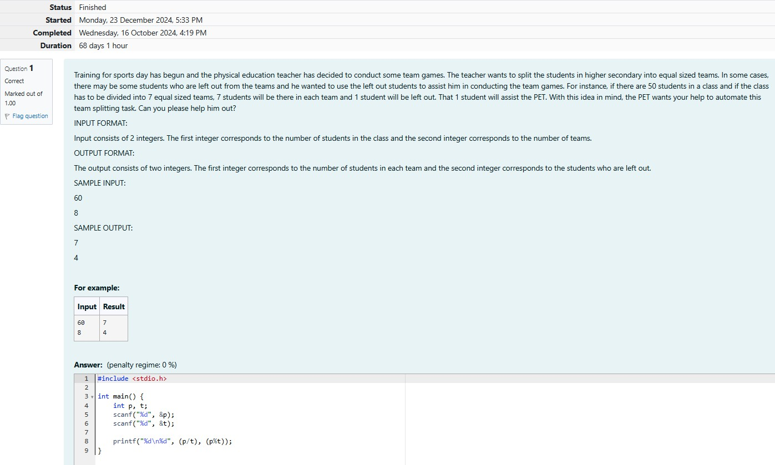

Output:

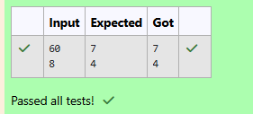

# TheNewspaperAgency

Q1)EachSunday,anewspaper agencysellswcopiesofaspecialeditionnewspaperforRs.xpercopy.The cost to the agency of eachnewspaper is Rs.y. The agency pays a fixed cost for storage, delivery and so on of Rs.100 per Sunday. The newspaper agency wants to calculate the profit which it obtains only on Sun- days. Can you please help them out by writing a program to compute the profit if w, x, and y are given?

## INPUTFORMAT:

Inputconsistsof3integers:w,x,andy.wisthenumberofcopiessold,xisthecostpercopyandyisthe cost the agency spends per copy.

## OUTPUTFORMAT:

Theoutputconsistsofasingleintegerwhichcorrespondstotheprofitobtainedbythenewspaperagency. SAMPLE INPUT:

1000

2

1

## SAMPLEOUTPUT:

900

Forexample:

|  |  |
| --- | --- |
| **Input** | **Result** |
| 1000 |  |
| 2 | 900 |
| 1 |  |

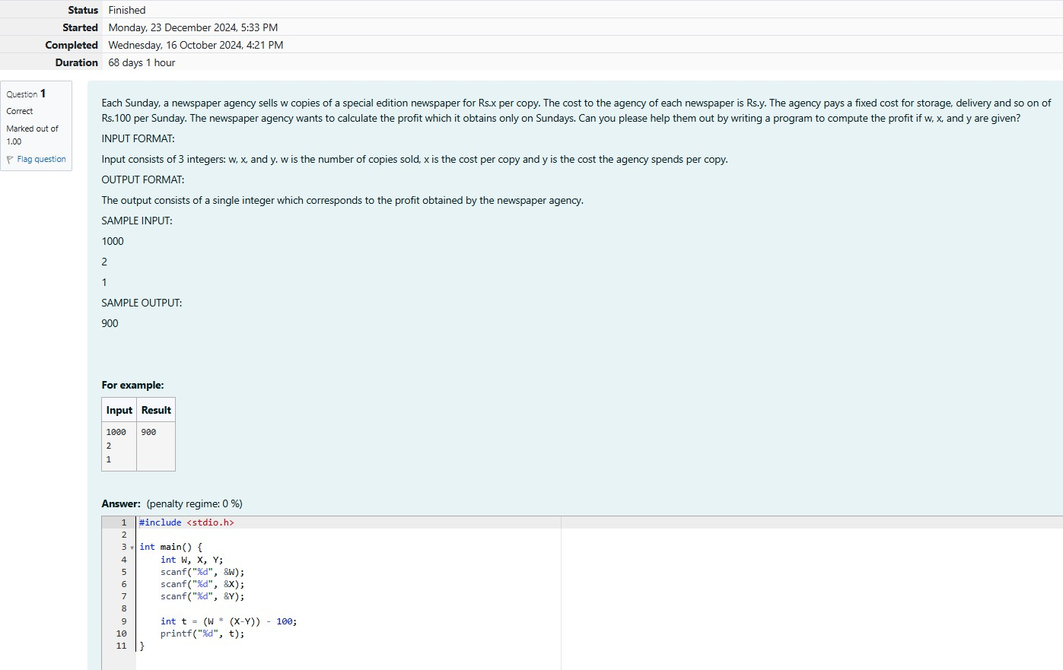

**Output:**

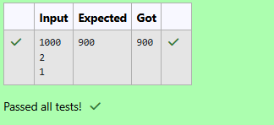

# TheChroniclesof Narnia

Q1)Four kidsPeter,Susan,EdmondandLucytravelthroughawardrobe tothe landofNarnia.Narniais a fantasy world of magic with mythical beasts and talking animals.While exploring the land of narnia Lucy found Mr.Tumnus the two leggedstag ,and shefollowed it,down anarrowpath .She and Mr.Tumnus be- came friends and he offered a cup of coffee to Lucy in his small hut.It was time for Lucy to return to her familyandsoshebidgoodbyetoMr.TumnusandwhileleavingMr.Tumnustoldthatitisquitedifficultto find the route back as it was already dark. He told her to see the trees while returning back and said that the first tree withtwo digits number will help her find the way and the way to go back to her home is the sum ofdigitsofthetree andthatnumberedwaywillleadherto the tree nextto thewardrobewhereshe can find the others. Lucy was already confused, so please help her in finding the route to her home....

InputFormat:

Inputconsistsofanintegercorrespondingtothe2-digitnumber. Output Format:

Outputconsistsofanintegercorrespondingtothesumofitsdigits. SAMPLE INPUT:

87

## SAMPLEOUTPUT:

15

Forexample:

|  |  |
| --- | --- |
| **Input** | **Result** |
| 87 | 15 |

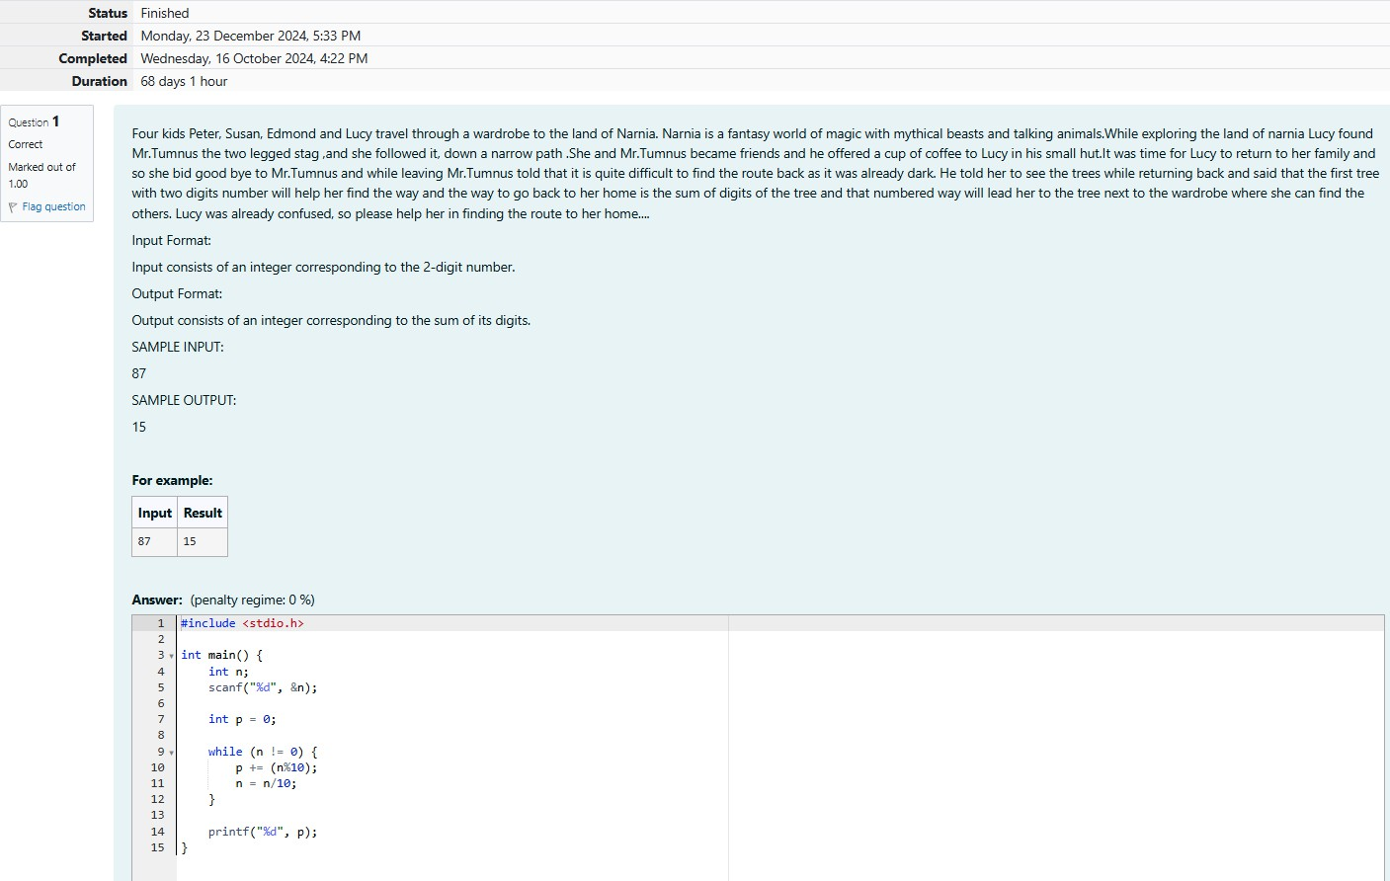

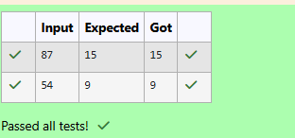**Output:**